🚀PR03: Referential Integrity
With Restricted and Cascade Constraints

(35%)Question 3.1: According to the Referential Diagram below, which of the following statements about foreign keys is NOT TRUE? (7 answers.)
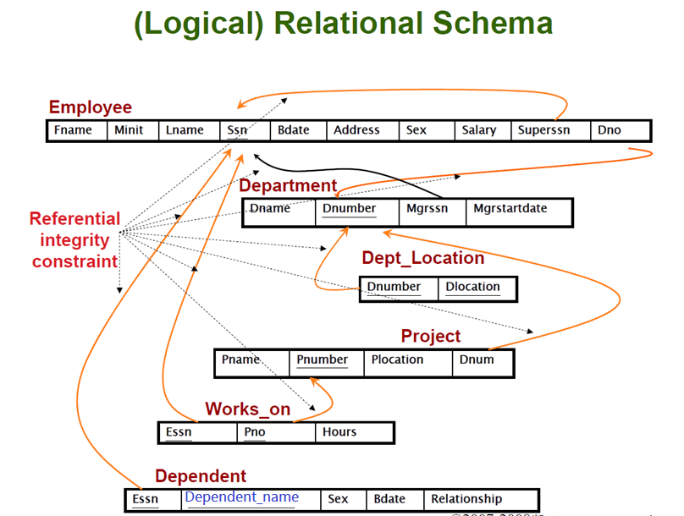
- A foreign key is a field (or collection of fields) in one table that may refer to the PRIMARY KEY in the same table. This reference is referred to as a self-reference.
- A foreign key cannot be NULL.
- A foreign key value in a child table must match an existing value in the referenced primary key value of the parent table or be NULL.
- A foreign key must contain unique values.
- Foreign keys do not need to have the same uniqueness as primary keys.
- Foreign keys can have repeated values in the child table.
- Primary and foreign keys have the same data types and come from the same domain.
- Since each foreign key value must exactly match the corresponding primary key value, the foreign key and the referenced primary key must be the same names.
- A composite foreign key consists of two or more columns in a child table that references a composite primary key in the parent table.
- In standard relational models, a foreign key gives access to another entire database.
- A foreign key can directly identify another column.
- A foreign key can directly identify another tuple (or instance).
- When drawing ER or relational diagrams, foreign key arrows typically point from PK to FK fields.
- Multiple foreign keys in different child tables can reference the same primary key in one parent table.
- Assume we have this record in the Department table:
INSERT INTO Department (Dname, Dnumber, Mgrssn, Mgrstartdate)
VALUES ('Engineering', 5, 'A123456789', '1998/08/01');
Now, insert an employee who belongs to department 5; this insert operation will succeed.
INSERT INTO Employee (Fname, Minit, Lname, Ssn, Bdate, Address, Sex, Salary, Superssn, Dno)
VALUES ('John', NULL, 'Wang', 'A123456789', '1999/06/05', NULL, ‘M’, 54300, 'A987654321', 5);
- Again, insert a new employee who is not yet assigned to a department; this insert operation will succeed.

INSERT INTO Employee (Fname, Minit, Lname, Ssn, Bdate, Address, Sex, Salary, Superssn, Dno)
VALUES ('Alice', NULL, 'Lee' , 'B223456789', '2001/04/03', NULL, ‘F’, 34500, NULL, NULL);
Answer: B、D、H、J、K、L、M、

(5%) Question 3.2: From the above Referential Diagram, the “Employee” relation owns the PK (Ssn) as well as FK (Superssn).
What is the relationship between these two keys Ssn: Superssn?
(A) 1 : 1 (B) 1 : M (C) M : 1 (D) M : N
Answer: B

(5%) Question 3.3: From the above Referential Diagram, the “Employee” relation has the PK (Ssn) and the “Dependent” relation has the PK(Essn, dependent_name). Assume the “Dependent” relation is converted from a multi-valued attribute of the “Employee” relation.
What is the relationship between the “Employee” and the “Dependent” tables?
(A) 1 : 1 (B) 1:M (C) M:1 (D) M:N
Answer: B

(5%) Question 3.4: From the above foreign key reference diagram, the PK (Ssn) of the "employee" table and the FK (Mgrssn) of another "department" table are related to each other.
If it is the business rule that allows the head of each department CAN concurrently serve as the head of other departments, and each department can only have one head. What is the relationship between the "employee" and "department" tables in terms of managerial role?
(A) 1 : 1 (B) 1:M (C) M:1 (D) M:N
Answer: B

(5%) Question 3.5: From the above foreign key reference diagram, the PK (Ssn) of the "employee" table and the FK (Mgrssn) of another "department" table are related to each other.
If it is the business rule that enforces the head of each department CAN NOT concurrently serve as the head of other departments, and each department can only have one head. What is the relationship between the "employee" and "department" tables in terms of managerial role?
(A) 1 : 1 (B) 1:M (C) M:1 (D) M:N
Answer: A

(5%) Question 3.6: What are the properties of foreign keys enforced by the Referential Integrity Constraint?
(A) uniqueness
(B) can be duplicated, but must match the value of the primary key
(C) not null
(D) may be null
Answer: B、D

(5%) Question 3.7: According to the PR3.1_School_PKFK file, you have already created four relations (tables) as well as the three relationships.
There is a relation (table) with three attributes that serve as both a primary key (PK) and the foreign keys (FK). Please list the name of this table and its three attributes.

Answer:
Table name: CLASSES
Three attributes: eid、sid、cno

(5%) Question 3.8: Write a SQL statement to insert a new tuple into the "Classes" relation (table) and explain why an error message occurs.
('E001','S007','CS101','12:00:00','180-M', 80);
Answer:
SQL Statement :
insert into classes values('E001','S007','CS101','12:00:00','180-M', 80);

Reason: 主鍵soo7不存在因此無法新增到classes

(5%) Question 3.9: Since the referential integrity constraint enforces that a foreign key value in a child table must match an existing value in the referenced primary key value of the parent table or be NULL, why can we not execute the SQL statement to insert a new tuple into the "Classes" relation (table)? Please explain why an error message occurs.
('E001', NULL,'CS101','12:00:00','180-M', 80);
Answer:
SQL Statement :
insert into classes('E001', NULL,'CS101','12:00:00','180-M', 80);
Reason:主鍵不能為NULL

scenario:
Consider the two relational schemas: “Classes” references the “Students” tables.
Here, assume that professor 'Amy Wang' with ID as 'E003' decides to retire. What would the DBMS do if the situation occurred? Amy’s information should be removed from the database.

(5%) Question 3.10: Write a SQL statement to delete the tuple with eid ='E003' from the “instructors” table and explain why an error message occurs.
Answer: SQL Statement : ______________________________
Why does the error message occur:_________________________

(10%)Question 3.11: Please observe the “Deletion Rule” and “Update Rule” under the "INSERT and UPDATE specifications" in SQL Server. SQL Server provides different Specifications for managing the effect of updates and deletes on child table values. What are all four actions be used in SQL Server effectively without threatening the referential integrity?
Answer:
(1)
(2)
(3)
(4)

(5 %) Question 3.12: According to Step 8, please use screenshot to show the data instances of the “instructors” and “classes” relations.
Answer:

      - (5 %) Question 3.13: Execute the “PR3.2School(restriction mode).sql” file.
At this stage, the four tables exist but are not yet connected by any relationships, as shown in the diagram below.
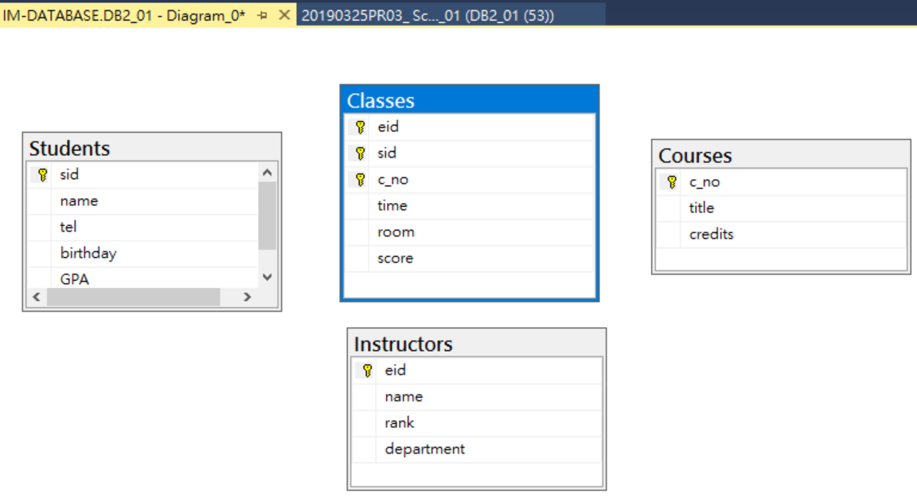
How to use SQL syntax to define foreign key constraints with the CASCADE option to establish the relationships between (courses and classes), (students and classes) and (instructors and classes) tables.

ON DELETE CASCADE
ON UPDATE CASCADE
Answer: The SQL statements are:

alter table_______________
____
constraint ___________________ ,
constraint ______________,
constraint ___________;

